Bored of small-talk and humus, Themers are grown-ups who have brought kids’ play back into their otherwise responsible, professional lives.

There are two gatherings in the park on a sunny afternoon.

The first is made of several couples in their thirties wearing casual khakis and muted shirts. The women stand in one circle drinking wine while the men stand in another drinking beers. Kids run between them and around the little folding table holding the chips and potato salad.

The trees around the second gathering, on the other hand, are strewn with flags, balloons and colourful streamers. Here are the same aged young families but also singles and same-sex couples sitting and standing and moving in between the various clusters. Their clothes are brighter, more colourful –with a smattering of cowboy hats and sequins. Looking closer, we see that many are dressed in sporting outfits circa 1970s complete with sweatbands and tube socks pulled up the knees. We soon see why as two men lay out hoola-hoops, huge foam mats, and Frisbees and begin to hoist a giant sign between two trees that reads “Matt and Rays 2nd Annual Olympic Games.”

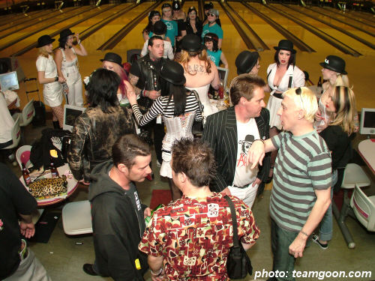
These are the Themers. Communities of adults, made up of mostly professionals, that have sprung up in the larger cities all over the western world. They are perhaps best known for their theme-styled clothing which jumps easily from era to era: 1940s Hong Kong one moment to 1960s SOHO the next. Looks that were once relegated to BBC period dramas or to fancy-dress parties are now seen on the street and even in the boardroom, particularly in the creative industries of design, media and high tech.

Not all Themers are so extreme in their dress. Most mix today’s high-end fashions with a single unique piece from an op-shop, rather than an entire outfit. Yes, the seeds of this trend began in the 80s with the likes of Madonna and later with Gwen Stefani. But while these performers changed their styles several times throughout their careers, Themers do so daily. Furthermore, while current evening ware styles can often drift into the realm of costume in its dramatic appeal, the Themer day wear is more subdued with great focus on the authenticity of the cut and fabric.

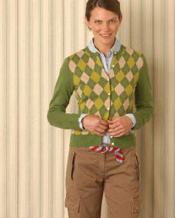



But the true heart of the Themers movement is their approach to socializing. They don’t just get together to watch the game, they dress in team colours and arrange an informal betting pool. Birthday parties are progressive-dinner/treasure hunts, Barbeques include yard games such as Tag or Red Rover and dinner parties involve a hands-on cooking lesson from a well-known chef or a short Salon on the topic of the history of the walnut economy.
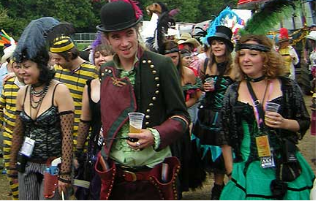
Unlike Ravers which were largely based around the drug ecstasy, Themers rely on interactive games and creativity to form bonds. In the beginning, they found they needed to introduce word play and structured questions in order to regain the socialization they had lost. However, what quickly followed was the great re-birth of the party trick.

Themers homes are filled with board games and toys. Instead of a single new car, they own several used cars in various models to suit their moods. Aside from the minority who reject technology, most are bloggers or videoers who use these tools to record their events and share their ideas with others.

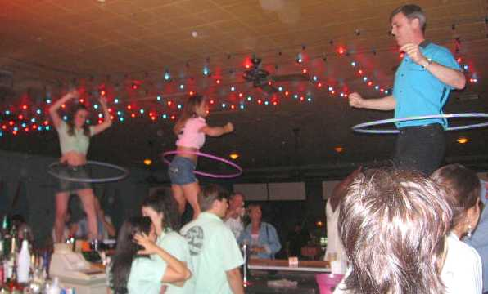
Criticized by some as frivolous and immature, Themers argue that joy is a valuable goal and is only just now being recognized as having an economic value. Many have also pointed out that being a Themer is only one part of their lifestyle and does not over-shadow their professional lives or their volunteer work. In fact many claim that their participation in the Themers activities has shown them how to get out of the house and participate in a way they previously avoided.

Indeed, their Cre-activity Manifesto states that community doesn’t simply happen but is proactively created. It calls for people to turn off the television and get together to socialize. It also pushes the democratisation of art and the power of everyday creativity. Railing against the high prices and snobbery of gallery art, it encourages ordinary people to make and share their own pieces. The popularity of the homemade greeting card, for example, has hurt Hallmark as much as it has helped Crayola and other raw materials manufacturers.

In addition to the traditional 3rd Place venues such as local cafes and pubs. Themers are drawn to a whole series of 4th Place spaces including parks, 10 pin bowling alleys and a growing number of venues that offer pre-arranged decorations and costumes for guests to use for the night.

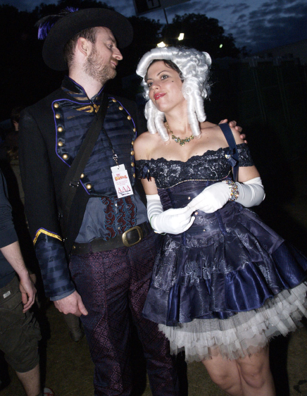
The hard-core Themers are wary of the more commercial offerings citing the main point of the early movement is the very act of putting yourself into the planning. As one Themer recently explained, “When guests have to prepare for the event, by making a costume or practicing a performance, they are laying the groundwork long before they arrive. By the time the party starts, they are fully participating.” It is this conscious focus, they argue, that allows community to foster. They worry that these places which carry huge costume wardrobes on site, make it too easy.

More popular are the so called ‘blank pallet’ venues who allow their space to be altered for the night and turn over their kitchens to the growing number of freelance specialty chefs.

Some say Themers are also responsible for the spike in ‘participation travel’ which includes historical re-enactments and the popular ‘for a day’ series which started with Roadie For a Day and has expanded into a mind boggling number of occupations and lifestyles that travellers can experience.

Finally, although they passionately support the community building values of the lifestyle, most Themers reject the label itself. They are fearful of re-creating communities of the past that are built upon static and often rigid roles. Instead they consciously slip between eras, cars, social groups, and even accents in order to be free from being identified as any one thing. Including a Themer.

